FIGURE 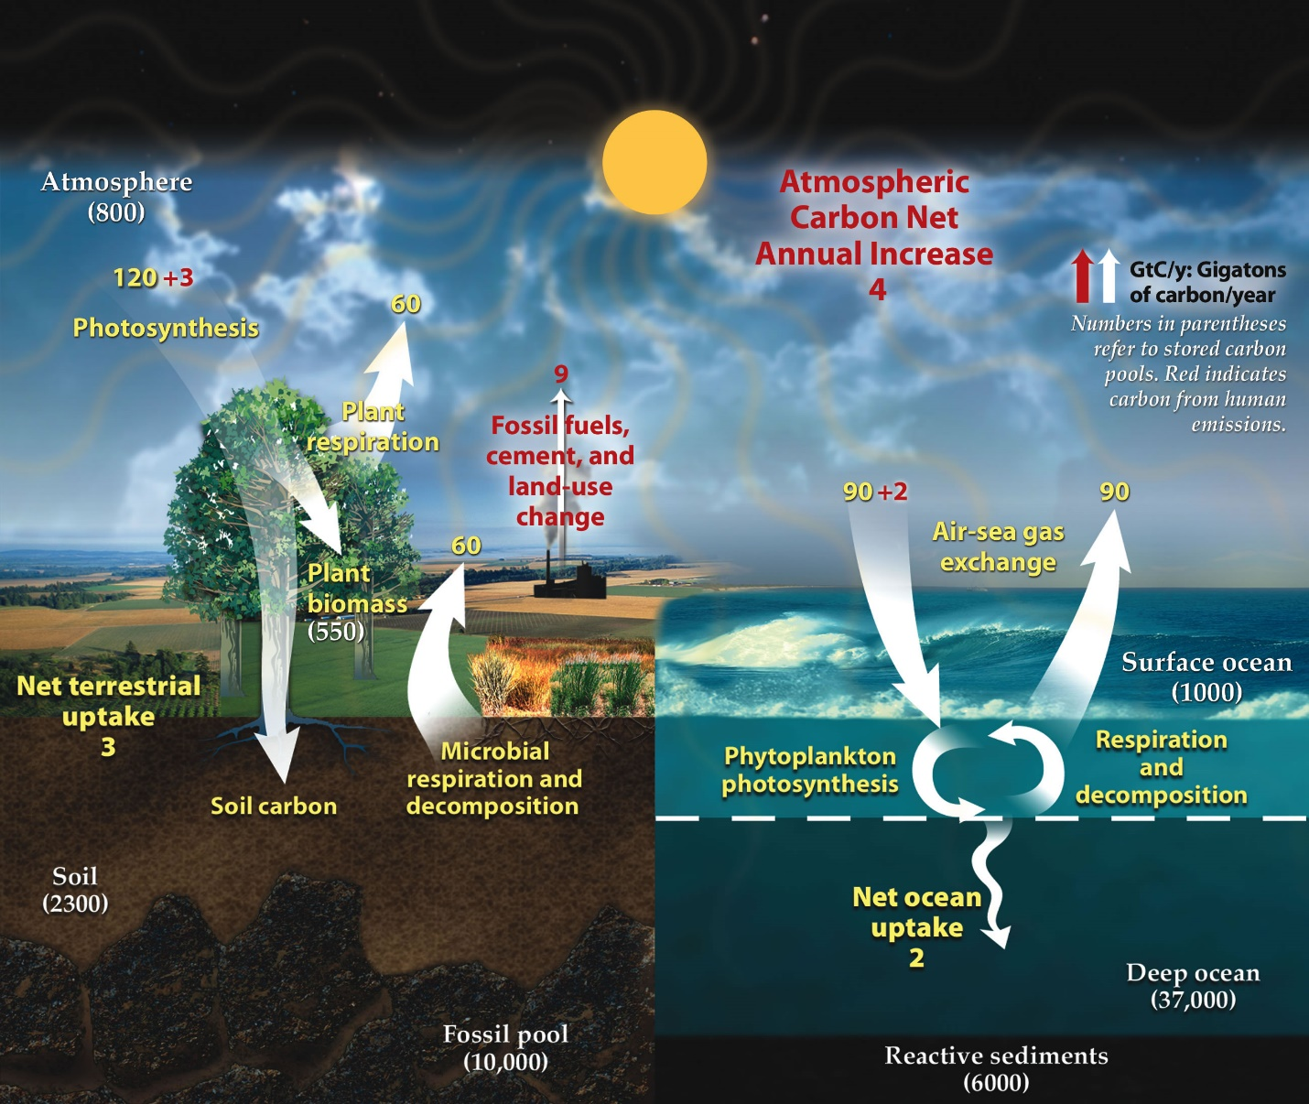
The first of three lessons, this worksheet and activity introduces students to the different places on Earth the carbon is stored, also known as carbon pools or carbon reservoirs.

Drawing the Carbon Cycle
The first activity on the worksheet is for students to draw a carbon cycle or anything with carbon in it (depending on the age and knowledge base of the students). This gets the students thinking about things that have carbon in them and gives them some liberties in artistic expression. They will also add to this drawing as the lesson continues and they learn more. At the end, make sure every student has the 5 main mobile carbon pools in their drawing (Atmosphere, Plant/Animals, Shallow Ocean, Soils, Fossil Fuels). Explain to the students why we are not considering carbon in the deep ocean and rocks (much longer than human time scales).

Calculations
Students should know how to calculate percentages from their math classes, but if they are struggling with this concept, you can do a quick refresher on the board. Then, do the first of the mobile carbon pools (Atmosphere) on the board. Assign each of the other ones to students in each part of the room, then share answers at the end.

Building the Carbon Cycle Model
Have the students come up to the front and put the representative amounts of each material in their plastic water bottles. The plastic water bottles can be replaced by any water-tight container. Fossil fuels can be easily represented by gravel, leaves can represent plant/animal carbon, tap water for shallow ocean, and garden soil for soil carbon. Getting students to go up and put each of these materials in can be hectic but make it fun!

Reflecting
Make students each come up with questions about how carbon moves from one pool of carbon to the other. Call on students and answer these questions while editing their initial drawing to incorporate arrows connecting their mobile carbon pools.

