Name:
Date:

Your Local Water Cycle
In this activity, you’ll get to know some of your local water bodies and the role they play in your local water cycle! Using Google Maps, browse your local area and look for nearby water bodies (rivers, streams, lakes, oceans, snowpack, etc.). Select four of these water bodies to report on, and then complete the following worksheet (see example below).
Note: Once you have identified your four water bodies, you’ll want to give the coordinates of each site. Do this by dropping a pin on your site, scrolling down to find the coordinates, and tapping the coordinates to copy them to your clipboard (your teacher will show you how to do this in class).
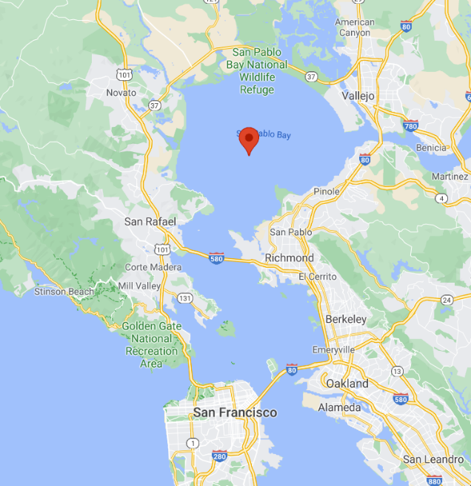
Example worksheet:

Site Name: | San Pablo Bay (near San Francisco, California)
Type: | River  Lake  Ocean  Snowpack  Other:
Coordinates: | 38.0553948, -122.3930929

List sources that feed this water body (and associated phases of the water cycle) | Sacramento River (runoff), Napa River (runoff), Petaluma River (runoff), other smaller creeks (runoff), rainfall (precipitation)
List ways that water leaves this water body (and the associated phases of the water cycle) | Evaporation
Site 1 picture:

Site Name:
Type: | River  Lake  Ocean  Snowpack  Other:
Coordinates:

List sources that feed this water body (and associated phases of the water cycle)

List ways that water leaves this water body (and the associated phases of the water cycle)

Site 2 picture:

Site Name:
Type: | River  Lake  Ocean  Snowpack  Other:
Coordinates:

List sources that feed this water body (and associated phases of the water cycle)

List ways that water leaves this water body (and the associated phases of the water cycle)

Site 3 picture:

Site Name:
Type: | River  Lake  Ocean  Snowpack  Other:
Coordinates:

List sources that feed this water body (and associated phases of the water cycle)

List ways that water leaves this water body (and the associated phases of the water cycle)

Site 4 picture:

Site Name:
Type: | River  Lake  Ocean  Snowpack  Other:
Coordinates:

List sources that feed this water body (and associated phases of the water cycle)

List ways that water leaves this water body (and the associated phases of the water cycle)

Select one of your four sites and draw a simple model showing how water enters and exits your water body. Use arrows to show how water enters and leaves via evaporation, precipitation, runoff, etc, and label any lakes, creeks, and other features with their names. Your teacher will provide an example for you.

Once you are done reporting on your four sites, answer the following questions:
Do you notice any links between the four sites you have selected? Do rivers connect your sites, or is there another way that water can travel between your sites?
If yes, what phases of the water cycle connect your sites?

