Name_________________________
Date__________________________

Construct the Jordan River Food Web
Instructions: Using the species you observed during the Jordan River field trip (recorded on your wildlife observation worksheet and on iNaturalist), create sketches of potential Jordan River food webs. See example below:
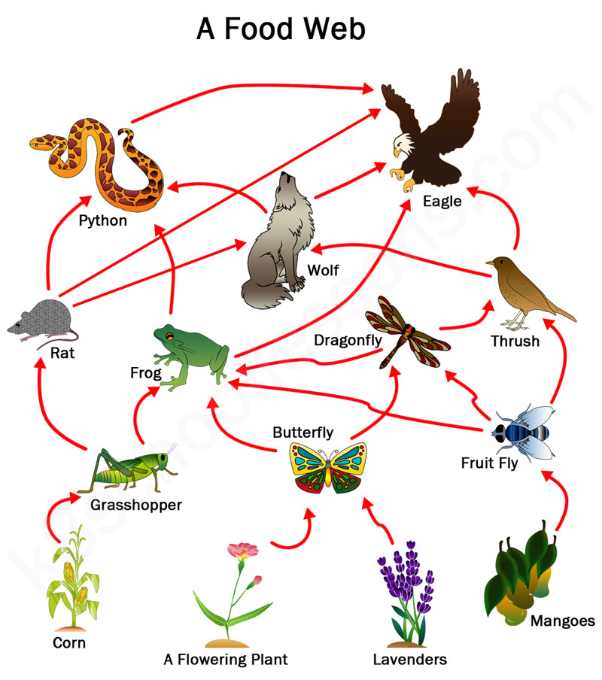

Sketch each element of the food web and label with both common and scientific name. Also classify each organism as a primary producer (PP), primary consumer (PC), secondary consumer (SC), or tertiary consumer (TC). Work in groups of 3 to complete this activity, but each student will turn in their own sheet at the end of the class period.
Sketch your food web here:

